
Setting Up Multi-Factor Authentication (MFA)
Step by Step
Multi-Factor Authentication (MFA) adds a second layer of security to your college account. Once enabled, signing in will require both your password and a code from the Microsoft Authenticator app on your phone. Follow the steps below to set it up.
Step 1: Open the MFA setup page

From your mobile device, scan the QR code with your phone's camera, or type the link below into the address bar:
https://aka.ms/setupmfa

Step 2: Sign in with your school account
When prompted, sign in with your mainecc.edu school email address and password
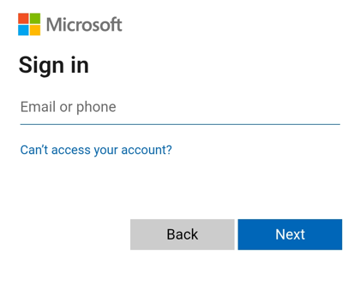

Click on Add sign-in method and choose Microsoft Authenticator
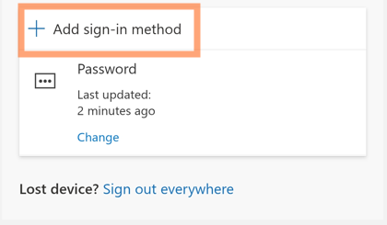

Step 3: Install the Microsoft Authenticator app
On your phone, install the free Microsoft Authenticator app from your device's app store using the link below. Return to this prompt and click Next.
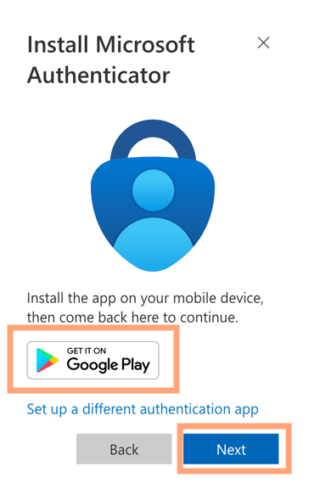

Step 4: Pair your account
On your phone, select “Pair your account to the app by clicking this link”
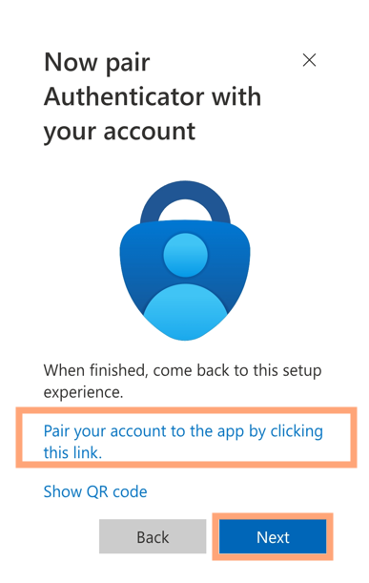

Your phone will pair with the app, click the Next button
Step 5: Approve a test sign-in
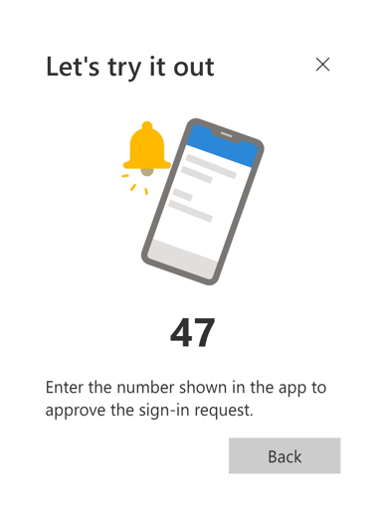

The app will automatically prompt for a security code, enter the number displayed on your device to try it out
Step 6: You're done!
You'll see confirmation that the Authenticator has been added. From now on, when you sign in to your school account, you'll be asked to approve the sign-in from your phone.
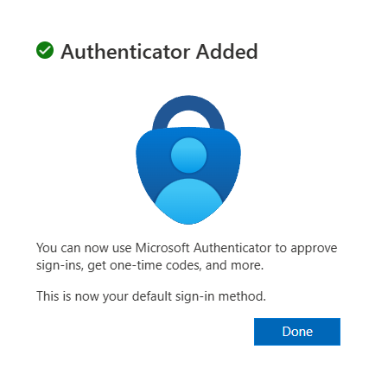


Need help?
If you get stuck or need to set up MFA on a new phone, contact
the IT Help Desk at ithelp@mainecc.edu or by calling 207-331-9666

