**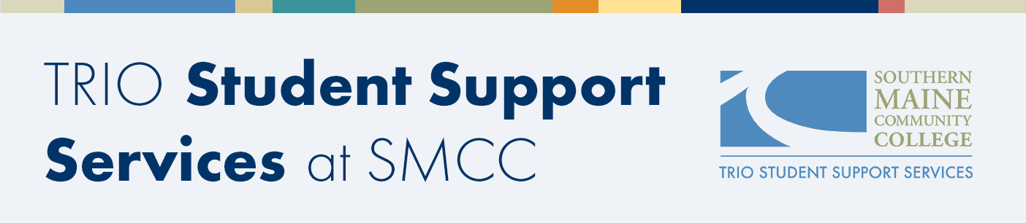  
  
TRIO SSS Interest Form**

**Thank you for your interest in TRIO Student Support Services (SSS). TRIO SSS has limited space and federal eligibility regulations that require us to verify specific information. Please contact us if you have any questions.**

**Today’s date: ____________________**

**Student Information:**

**Name:**

First Middle Last

**Date of Birth:__                                   SMCC Student I.D. Number:**

**Pronouns:** □ He/Him □ She/Her □ They/Them □ Other ____________________

**Preferred mode of communication:** □ Phone □ SMCC Email □ Text

**Phone:**

To be eligible for TRIO support, you must meet at least one of the following criteria: 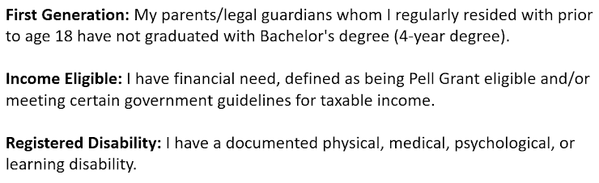

Eligibility *

Please check all that apply.

I am first generation

I am income eligible

I have a disability and have contacted SMCC's Disability Services Office

I have a disability and have not contacted SMCC's Disability Services Office

I am not sure

**Academic Goals:**

**What are your goals while at SMCC?**

□ Earn an Associate Degree or certificate at SMCC

(Please name program here: ___________________________________)

□ Earn an Associate Degree at SMCC and then transfer to a four-year institution

(Please name program here: ___________________________________)

□ Take classes at SMCC but not get a degree at SMCC

**How many classes do you plan to take each semester?** □ 1-2       □ 3-4   □ 4+

**My primary campus is:** □ So. Portland □ Midcoast □ Online

*Thank you for your interest in TRIO SSS at SMCC.*

*We will follow up with you soon.*

The Student Support Services projects at Southern Maine Community College are 100% funded by the U.S. Department of Education in the amount of $544,728 for the 2025-2026 fiscal year to serve 240 students.